Plan: **2 tools for Eric’s request**

This document is about the plan, requirements, designs and details about 2 tools that Eric requested for team Tier 3 Support to do.

This is written by Tier3 team – Nhan Thien Nguyen.

Version: 1.2.

Last Updated: 02/21/2019.

# **Table of Contents**

1. Overview the plan for both 2 tools 4

2. Connections to databases, security and permissions 6

3. The 1st tool - queries the warehouse database 14

4. The 2nd tool - queries the HHAX data feed 17

**Table of Figures**

Figure 1.1 Screen login 8

Figure 1.2 Screen choose the tool to access 9

Figure 1.3 Screen choose the warehouse database to connect 10

Figure 1.4 Screen choose the HHAX Integration database 11

Figure 1.5 Screen manage connections to databases 11

Figure 1.6 Popup Add/Edit warehouse database 12

Figure 1.7 Popup Add/Edit HHAX Integration database 12

Figure 1.8 Screen manage accounts and set permissions 13

Figure 1.9 Popup Add/Edit accounts 13

Figure 3.1 Screen reviewing clients in warehouse 15

Figure 3.2 Screen reviewing authorizations in warehouse 16

Figure 4.1 Screen review Patients in HHAX responses 18

Figure 4.2 Screen review authorizations in HHAX responses 19

**Table of Tables**

Table 1.1 Permissions and access rights 7

Table 1.2 Database table Accounts 7

Table 1.3 Database table Connections 8

Table 3.1 Filters of reviewing clients - 1st tool 15

Table 3.2 Filters of reviewing authorizations in 1st tool 16

Table 4.1 Filters of reviewing patients in 2nd tool. 18

Table 4.2 Filters of reviewing authorizations in 2nd tool 19

# **Overview the plan for both 2 tools**

**Tools:**

* 1st tool: Displaying member and authorization records, querying the warehouse accounts in production.
* 2nd tool: Displaying staged data from the HHAX data feed, able to review inbound member and authorization database.

**Total time for 2 tools:** 224 hours – 5 weeks 3 days (included self-testing)

* Login & connections, permissions: 64 hours – 1 week 3 days.
* Time for 1st tool: 96 hours – 2 weeks 2 days.
* Time for 2nd tool: 64 hours – 1 week 3 days.

**Total screens:** 10 screens and 3 popups.

* Login, choose the tool and choose the database: 4 screens.
* Manage connections to databases (Warehouse and HHAX Integration): 1 screen and 2 popups.
* Mange accounts: 1 screen and 1 popup.
* The 1st tool for querying the warehouse: 2 screens.
* The 2nd tool for querying the HHAX Integration: 2 screens.

**Spent time at least each week:** 20 hours (code tools and do tickets)

**Time start coding tools:** (After accepting this plan)

**Date to release 1st tool:** (After accepting this plan)

**Date to release 2nd tool:** (After accepting this plan)

**Technology Stacks:**

* 2 tools in 1 website – built from
  + Front end: ReactJS v16.
  + Back end: .NET (Restful APIs) with language C#.
  + Database: MS SQL– is stored in local files and also included in the site.
* Developer: 1 – Nhan Thien Nguyen.
* Server’s environment:
  + System: Windows Server.
  + Needed packages: NodeJS x64 for Windows, .NET Framework.

For more detail about the security and requirements, screens, … of each tool, please read my information below.

1. **Connections to databases, security and permissions**

**Total time:** 64 hours – 1 week 3 days.

**Connections to database:**

* The connections to database can only be set by Admin account.
* Admin account can easily add/edit/remove connections to database with the information: server name, login, password.

**Security:**

* The accounts ’s passwords must be encrypted so that they can’t be seen easily in the database.
* The tool supports concurrent logins with a session timeout of 15 minutes of no-activity to keep connections down.

**Permissions and access rights:**

* There are 2 types of account:
* ***Admin:*** This is the ***full-control******and access*** account, is ***provided from KMS*** and there’s only one.
* ***Normal user:*** Can ***only be used to login and access*** the tools. Normal users can be created by Admin, and are ***limited which tools to access***. The normal user can only access to the 1st tool or the 2nd tool, or maybe both 2 tools by Admin set.

|  |  |  |
| --- | --- | --- |
| ***Permission & Access right*** | ***Admin*** | ***Normal user*** |
| Add/Edit/Remove connections to databases. | **YES** | **NO** |
| Choosing the database to connect. | **YES** | **YES** |
| Add/Edit/Remove normal accounts. | **YES** | **NO** |
| Set permission of normal accounts: which tools they can access. | **YES** | **NO** |
| Access and use the tools. | **YES** – both 2 tools | **YES** – but limited which tools can be accessed by Admin. |

*Table 1.1 Permissions and access rights*

**Databases and schemas:** There are 2 tables.

* Table Accounts:

|  |  |  |
| --- | --- | --- |
| **Column** | **Type** | **Explain** |
| ID | Int | The primary key. |
| Username | Nvarchar(50) | ***Unique*** - The user name is used to log in. |
| Password | Nvarchar(150) | The password is used to log in – encrypted. |
| Is_Admin | Boolean | Is Admin or not. |
| Can_access_DW | Boolean | Can access 1st tool or not. |
| Can_access_HHAX | Boolean | Can access 2nd tool or not. |

Table 1.2 Database table Accounts

Constraints:

Primary Key: ID

* Table Connections:

|  |  |  |
| --- | --- | --- |
| **Column** | **Type** | **Explain** |
| ID | Int | The primary key. |
| Type_Connection_Name | Nvarchar(150) | “HHAX” or “DW” |
| Connection_name | Nvarchar(150) | ***Unique*** - Connection name (alias). |
| Server_name | Nvarchar(150) | Server name of the database. |
| Database_name | Nvarchar(150) | Database name of the database. |
| Username_database | Nvarchar(150) | Username is used to log in the database. |
| Password_database | Nvarchar(150) | Password is used to log in the database – encrypted. |

Table 1.3 Database table Connections

Constraints:

Primary key: ID

**Screens:** Total 6 screens and 3 popups.

* Screen 2.1: Login page.

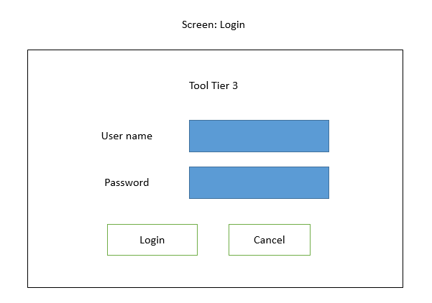

Figure 1.1 Screen login

* Screen 2.2: Choose the tool to use.

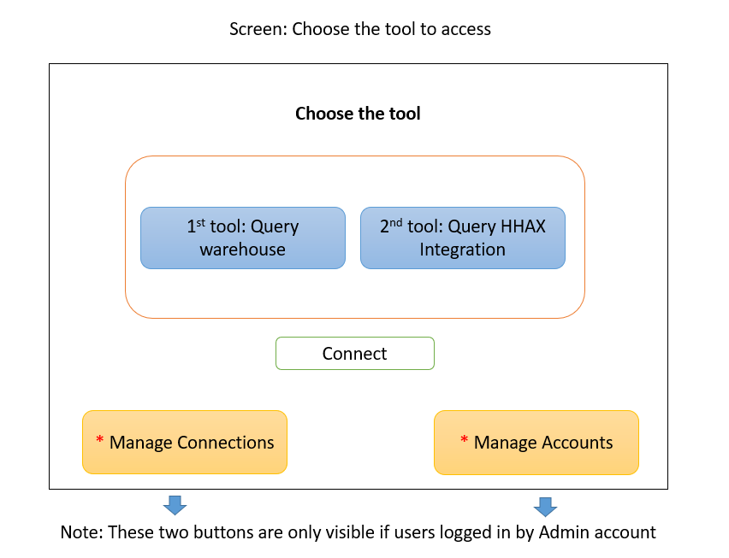

Figure 1.2 Screen choose the tool to access

* Screen 2.3: Choose the database to connect.
* If in screen 2.2: User selected the 1st tool to query in warehouse database

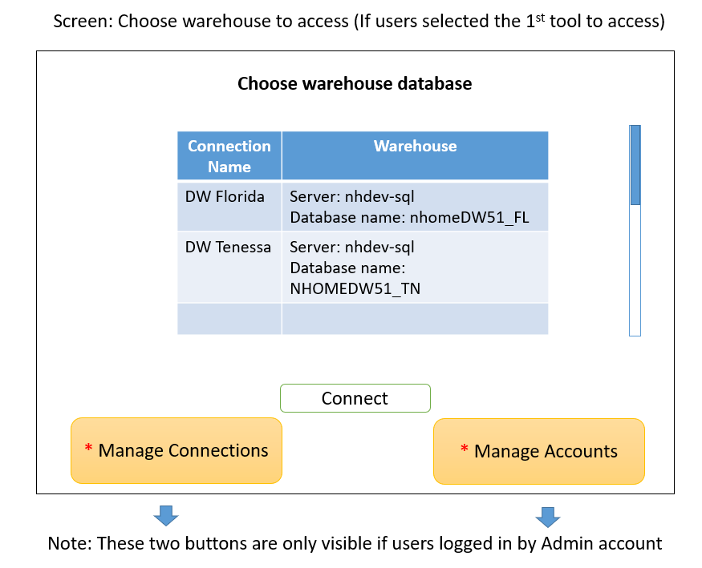

Figure 1.3 Screen choose the warehouse database to connect

* If users selected the 2nd tool to query in HHAX Integration.

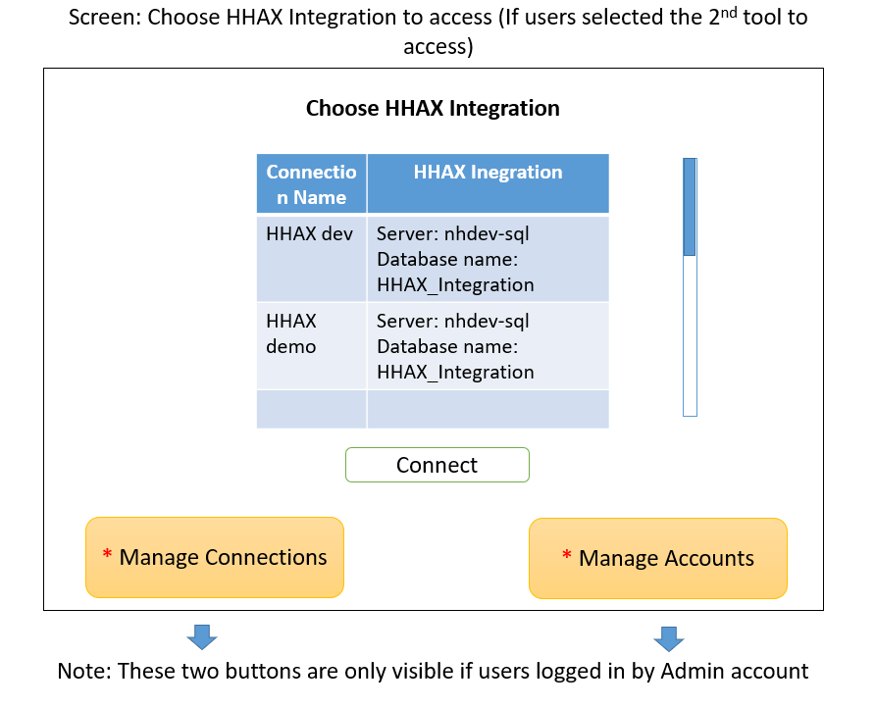

Figure 1.4 Screen choose the HHAX Integration database

* Screen 2.4: Manage connections to databases.
* From screen 2.3: If the user is Admin, then selected Manage Connections.

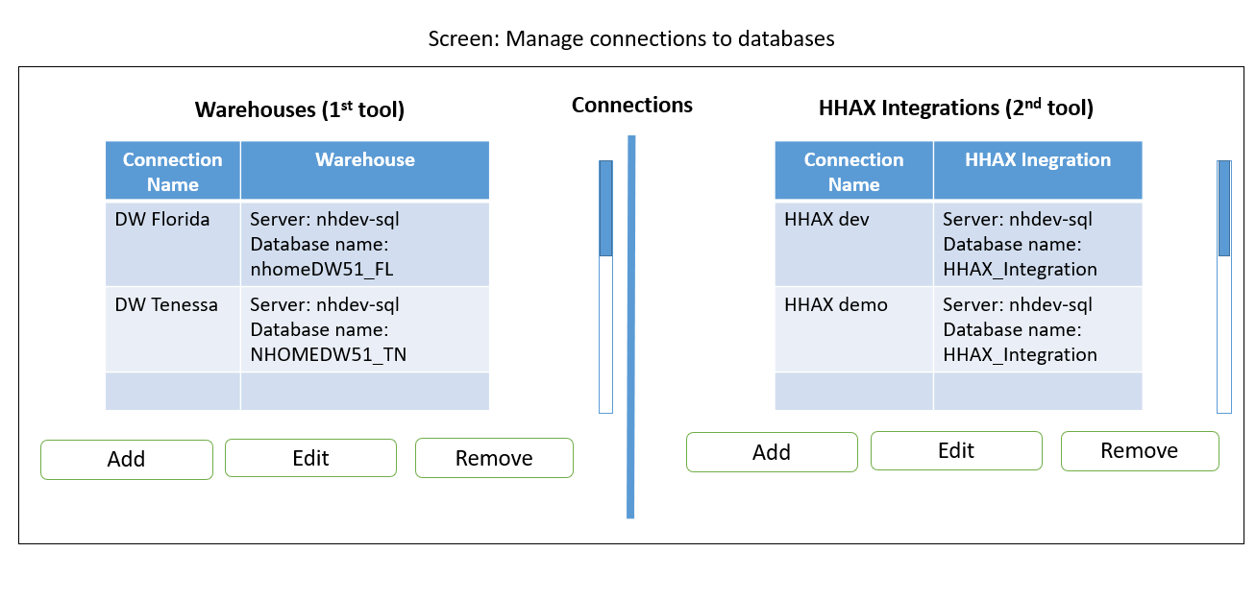

Figure 1.5 Screen manage connections to databases

* If Admin user selected Add/Edit in Warehouse, a popup will be opened like:

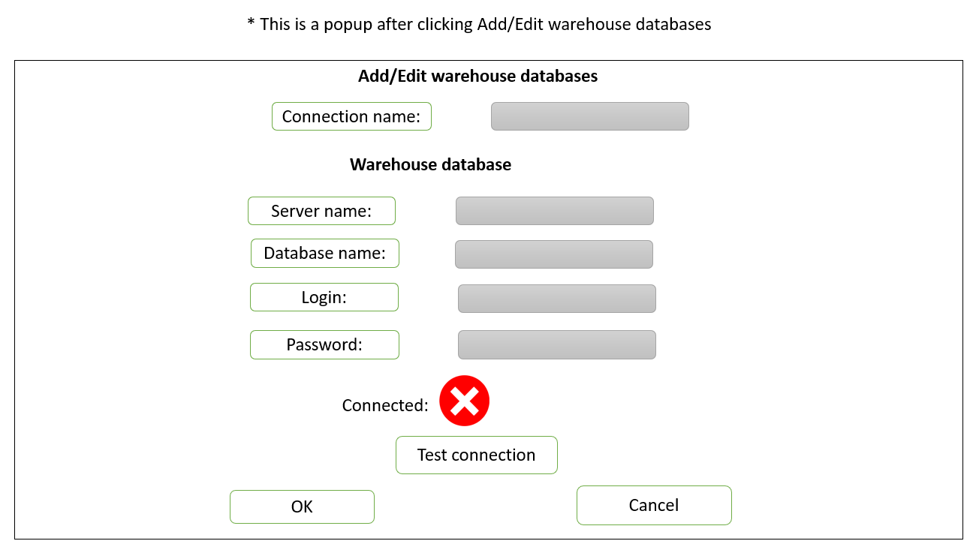

Figure 1.6 Popup Add/Edit warehouse database

* If Admin user selected Add/Edit in HHAX Integration, a popup will be opened like:

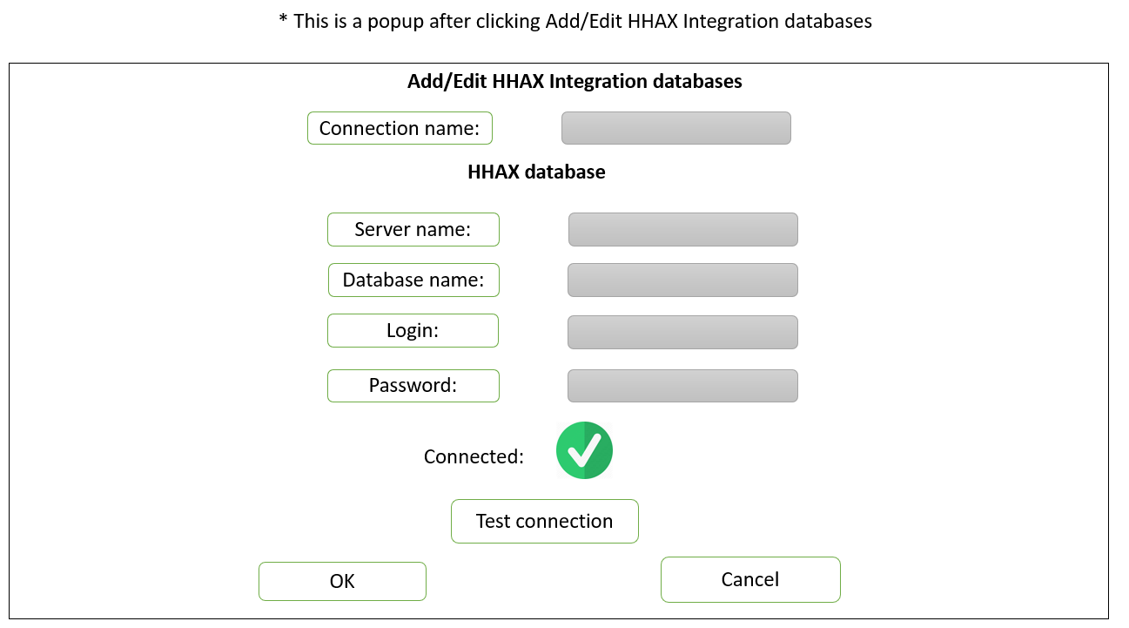

Figure 1.7 Popup Add/Edit HHAX Integration database

* Screen 2.5: Manage accounts.
* From screen 2.3: If the user is Admin, then selected Manage Accounts.

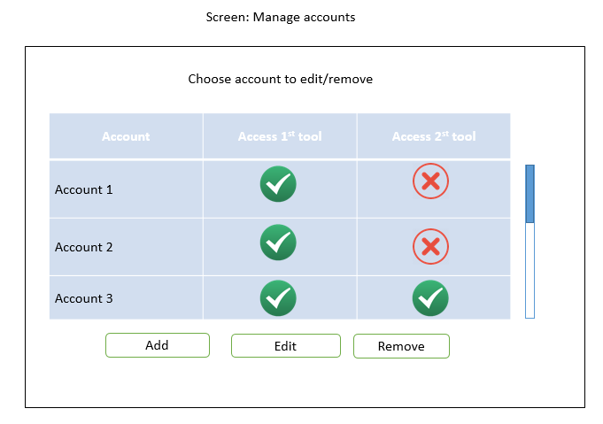

Figure 1.8 Screen manage accounts and set permissions

* When you click Add/Edit an account, a popup will be opened.

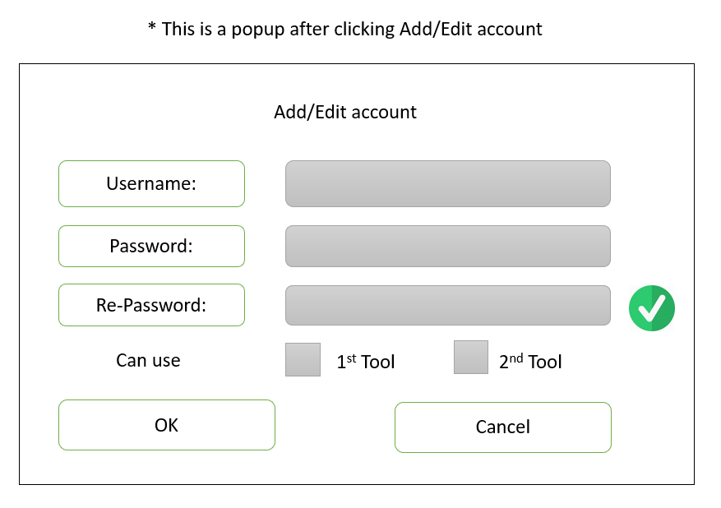

Figure 1.9 Popup Add/Edit accounts

# **The 1st tool - queries the warehouse database**

**Purpose:** A tool that can display member and authorization records for a specific jurisdiction, payer, combination. This tool queries the warehouse accounts in production to perform these lookups.

**Total time:** 96 hours – 2 weeks 2 days.

**Requirements:**

* Must use the valid accounts (the accounts are provided by KMS) and connected VPN to access, data accounts must be encrypted. ***(Included in 2nd chapter)***
* Provide way to set up the connection to the server of both warehouse database and HHAX integration, can be set on UI. ***(Included in 2nd chapter)***
* Have filters for reviewing imported Clients such as: Jurisdiction, First name, Last name, Member ID (to lookup clientOtherID), Admissions Type, ftpFileName, Row updated date range.
  + Query then show the data: Full name, Admission Type, clientOtherID, clientCustomID, diag10Code, rowCreated, rowModified, IsProcessed.
* Have filters for reviewing imported client’s authorization such as: Jurisdiction, ProviderID, First name and last name, Member ID (to lookup clientOtherID), Admissions Type, Services, Authrefno, ftpFileName, Date range of authorization, and Auth last updated (Date range filter).
* Authorization: Display the client’s full name, clientOtherID, admission type and client’s authorizations include: service, event code, authrefno, format, max, begin and end date, diag10Code, authVoided, authShared, rowCreated, rowModified, isProcessed,.

**Screens:** There are 2 screens – in two tabs.

* Screen 3.1: Searching the imported client.

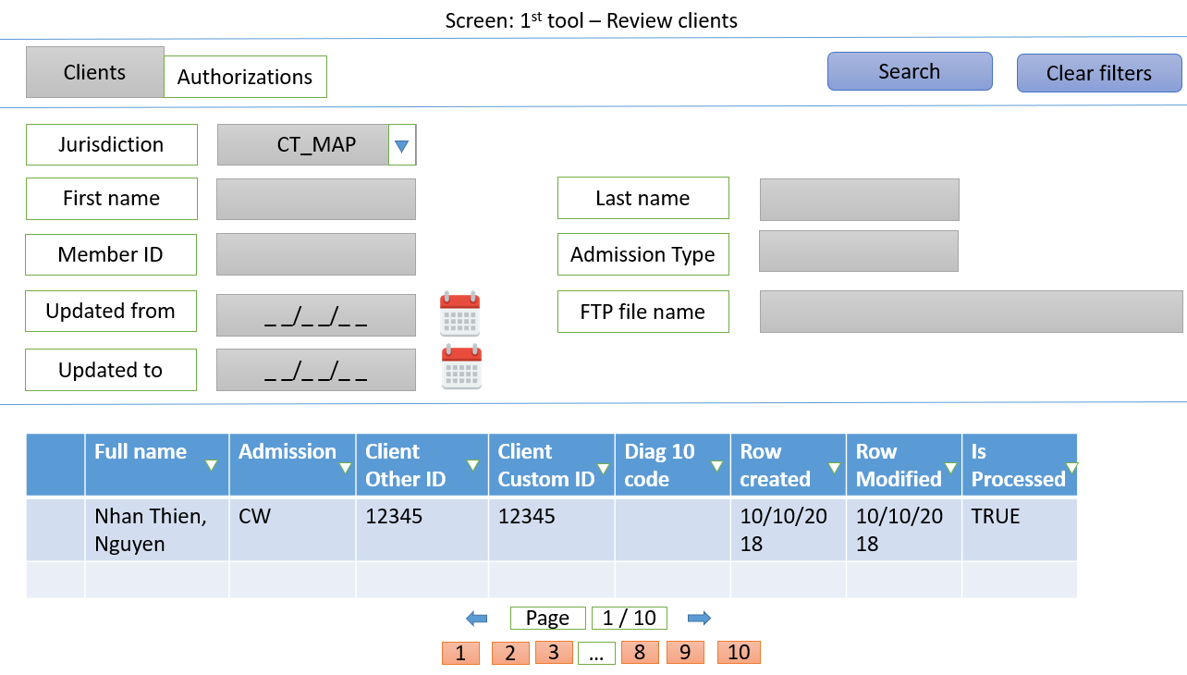

Figure 3.1 Screen reviewing clients in warehouse

|  |  |
| --- | --- |
| **Filter** | **From** |
| Jurisdiction | WarehouseDB/DataImportClient/JurisdictionID. |
| First name | Warehouse DB/DataImportClient/entFirstName. |
| Last name | Warehouse DB/DataImportClient/entLastName |
| Member ID | Warehouse DB/DataImportClient/ClientOtherID |
| Admission Type | Warehouse DB/Admissions_Types. |
| Update from | Warehouse DB/DataImportClient/RowUpdated. |
| Update to | Warehouse DB/DataImportClient/RowUpdated. |
| FTP File name | Warehouse DB/DataImportClient/FTPFileName. |

*Table 3.1 Filters of reviewing clients - 1st tool*

* Screen 3.2: Searching the imported client’s authorization.

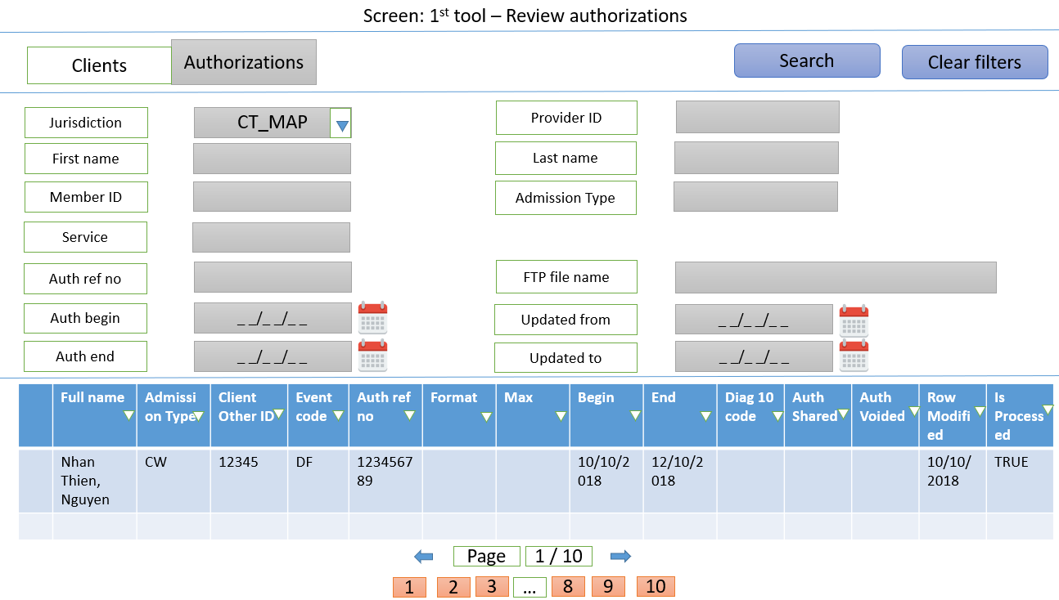

Figure 3.2 Screen reviewing authorizations in warehouse

|  |  |
| --- | --- |
| **Filter** | **From** |
| Jurisdiction | WarehouseDB/DataImport_Client/JurisdictionID. |
| Provider ID | Warehouse DB/ DataImport_Authorization/AgencyID |
| First name | Warehouse DB/DataImport_Client/entFirstName |
| Last name | Warehouse DB/DataImport_Client/entLastName |
| Member ID | Warehouse DB/ DataImport_Authorization /ClientOtherID |
| Admission Type | Warehouse DB/ DataImport_Authorization/adTypeID |
| Service | WarehouseDB/DataImport_Authorization/ServiceID |
| Auth ref no | WarehouseDB/DataImport_Authorization/authrefno |
| Auth begin | WarehouseDB/DataImport_Authorization/authDateFrom |
| Auth end | WarehouseDB/DataImport_Authorization/authDateTo |
| Update from | WarehouseDB/DataImport_Authorization/authUpdated |
| Update to | WarehouseDB/DataImport_Authorization/authUpdated |
| FTP File name | WarehouseDB/DataImport_Authorization/ftpFileName |

*Table 3.2 Filters of reviewing authorizations in 1st tool*

# **The 2nd tool - queries the HHAX data feed**

**Purpose:** A tool that can display staged data from the HHAX data feed. This provides the ability to review inbound member and authorization database.

**Total:** 64 hours – 1 week 3 days.

**Requirements:**

* Must use the valid accounts (the accounts are provided by KMS) and connected VPN to access, data accounts must be encrypted. ***(#Included in the 2nd chapter***)
* Have filters for reviewing client: Agency Name, Client first and last name, Patient ID, Admission ID, Patient status, MR Number, Inserted date range, Modified date range.
  + Query then show the records include: Patient ID, Patient’s full name, Admission ID, MR Number, Patient status, Discharge Date, Created date, Modified date, Invalid Data.
* Have filters for reviewing Patient’s authorization such as: Agency Name, Patient first & last name, Service, Admissions ID, MR Number, Authorization ID, Authorization Number, Date range of authorization, Inserted date range and Modified date range.
  + Query then show the records of authorizations group by Patient: Patient full name, Admission ID, MR Number, Authorization ID, Authorization Number, Service Type, Billing Service Code, Begin date, End date, Modified date and Invalid Data.

**Screens:** there are 2 screens – 2 tabs. They all are responses from HHAX to SANDATA.

* Screen 4.1: Search for Patients.

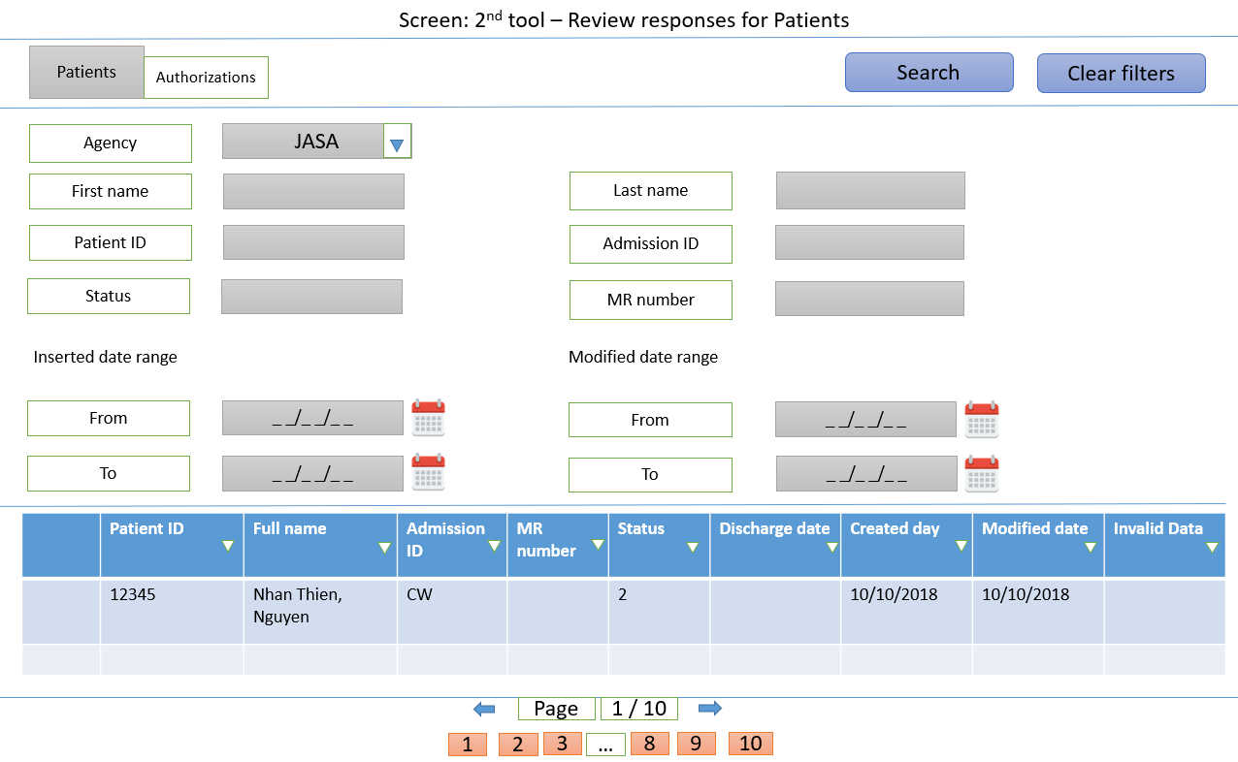

Figure 4.1 Screen review Patients in HHAX responses

|  |  |
| --- | --- |
| **Filter** | **From** |
| Agency | HHAX/Agency_Config/AgencyName |
| First name | HHAX/Patient_Demog/First_Name |
| Last name | HHAX/Patient_Demog/Last_Name |
| Patient ID | HHAX/Patient_Demog/Patient_ID |
| MR Number | HHAX.Patient_Demog.MR_Number |
| Admission ID | HHAX/Patient_Demog/Admission_ID |
| Status | HHAX/Patient_Demog/Patient_Status |
| Inserted date from | HHAX/Patient_Demog/Datetime_Inserted |
| Inserted date to | HHAX/Patient_Demog/Datetime_Inserted |
| Modified date from | HHAX/Patient_Demog/Modified_date |
| Modified date to | HHAX/Patient_Demog/Modified_date |

Table 4.1 Filters of reviewing patients in 2nd tool.

* Screen 4.2: Search for Patient’s authorizations.

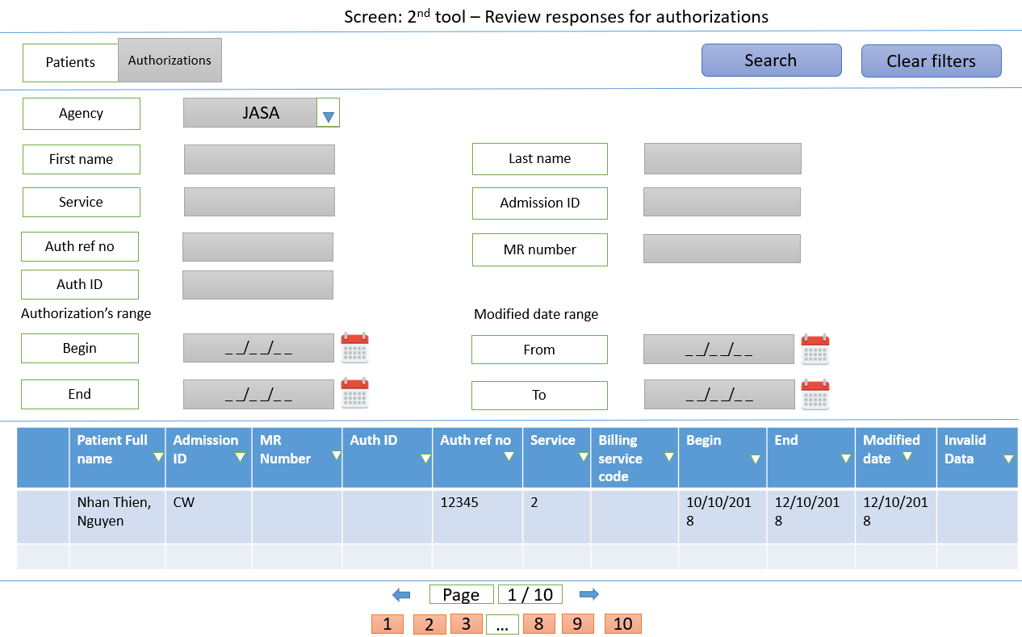

Figure 4.2 Screen review authorizations in HHAX responses

|  |  |
| --- | --- |
| **Filter** | **From** |
| Agency | HHAX/Agency_Config/AgencyName |
| First name | HHAX/Patient_Demog/First_Name |
| Last name | HHAX/Patient_Demog/Last_Name |
| Patient ID | HHAX/Patient_Authorizations/Patient_ID |
| MR Number | HHAX/Patient_Demog/MR_Number |
| Admission ID | HHAX/ Patient_Authorizations/Admission_ID |
| Service | HHAX/ Patient_Authorizations/Service_Type |
| Auth ID | HHAX/ Patient_Authorizations/Authorization_ID |
| Auth ref no | HHAX/ Patient_Authorizations/Authorization_Number |
| Auth begin | HHAX/ Patient_Authorizations/From_Date |
| Auth end | HHAX/ Patient_Authorizations/End_Date |
| Modified date from | HHAX/ Patient_Authorizations/Modified_Date |
| Modified date to | HHAX/ Patient_Authorizations/Modified_Date |

Table 4.2 Filters of reviewing authorizations in 2nd tool